School Magnetometers

## Cable / Connector Diagrams

#### Tim Taylor (photos Ciaran Beggan)

**Wiring Diagram:**

5V

**FG1** **FG2** **FG3**

GND +5V SYN O- O+ GND +5V SYN O- O+ GND +5V SYN O- O+

FG1 O- **Ther** Vf **LED**

O+

FG2 O- Vo

O+

FG3 O- V0

O+

Therm O

0V

9 cores required in cable

**Cable Colours:**

10 core cable (shielded) to be used.

Colour **Rd** **Or** Ye **Gr Bu Pu Bl Br Gy** Wh

Use **+5** **FG1+** FG2+ **FG3+ FG1- FG2- 0V FG3- The** xx

Pin # **1** **3** 4 **5 7 8 2 9 6**

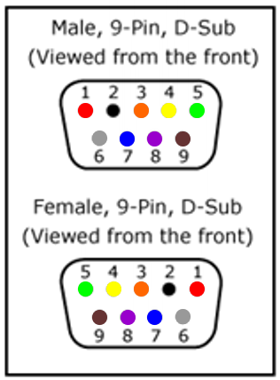 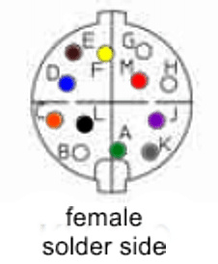 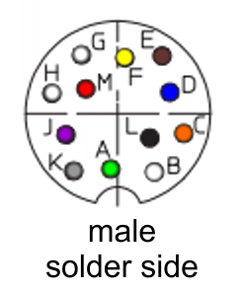

LED (wire under base)

TMP36 (wire under base)

FGM1

FGM2

FGM3

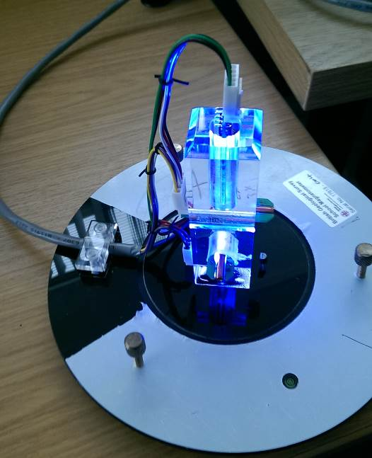

Connection to digitiser

Wire Tie

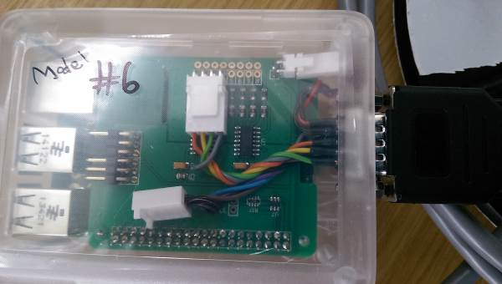

9-pin connector

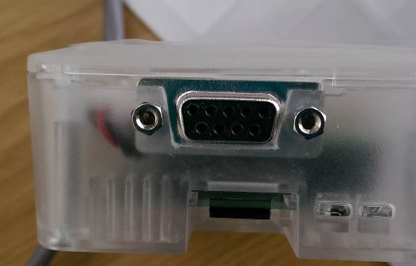

Extension cable to Raspberry Pi has round 12-pin connectors

